Module-2

Fundamentals of React Js

B1 What is React Js?

Ans:-React is a free and open-source front-end JavaScript library for building user interfaces based on UI components. Meta and a community of individual developers and companies maintain it.

B2 What is NPM in React Js?

npm is an abbreviation used for the **node package manager**. It is a package manager for JavaScript. It is the default package manager that comes with NodeJS when you install it.

B3 What is the Role of Node Js in react Js?

React and Node. js are two of the most popular open-source JavaScript frameworks, but they differ in their approach to a number of tasks. For example, while React is mainly used for building websites and user interfaces, **Node enables developers to build server-side code**.

B4 What is CLI command In React Js?

Command Line Input

CLI is **a command line program that accepts text input to execute operating system functions**. In the 1960s, using only computer terminals was the only way to interact with computers.

B5 What are the Components In React Js?

Components are **independent and reusable bits of code**. They serve the same purpose as JavaScript functions, but work in isolation and return HTML. Components come in two types, Class components, and Function components, in this tutorial we will concentrate on Function components.

B6 What are Header and Content Components in React Js?

Headers are **compositions that extend standard navbar functionalities**. They contain additional components like a jumbotron, sub-navbar, or image covers which serve as a container for extra navigation elements - usually links, forms, or call-to-action buttons.

I1 How to install React Js on Windows, and Linux Operating Systems?

## **Install Nodejs**

## Node.js provides a runtime environment to execute JavaScript code from outside a browser. NPM, the default package manager for Nodejs is used for managing and sharing the packages for any JavaScript project. React uses Node.js and NPM for the management of dependencies and runtime.

In this tutorial, we are going to install the create-react-app tool using the Node Package Manager(NPM). Create-react-app is a tool developed by the React.js team that makes React’s setting up easier.

So first, it needs to install Nodejs on our system. NPM will be installed with Nodejs. The current stable version of Node.js can be downloaded and installed from the official website which is given below.

[https://nodejs.org](https://nodejs.org/)

Download the latest version and install it. Here we can choose the LTS or the latest version. Because both of the version supports React.

After the installation, check the versions using the below commands.

node -v

npm -v

This will show the installed versions of Node.js and NPM.

Note:- If you are a beginner in this field, the guide [Steps to install Node.js and NPM on Windows 10](https://www.techomoro.com/install-node-js-and-npm-on-windows-10) will help you.

## **Create a New React Project**

After the successful installation of Nodejs and NPM, we can create a new React project by temporarily installing the create-react-app tool. Execute the below command on the Command prompt window.

npx create-react-app awesome-project

Here NPX will temporarily install create-react-app and create a new react project named awesome-project. Note that the awesome project is the name I have chosen for my react project.

## **Running the Application**

So the app we created can run locally on our system with the npm start command.

cd awesome-project

npm start

This will open up the react application in a new tab of our browser with the below URL.

http://localhost:3000

I2 How to install NPM and How to check the version of NPM?

### **Step 1: Download the Installer**

Download the Windows Installer from NodeJs' [official website](https://nodejs.org/en/download/). Make sure you have downloaded the latest version of NodeJs. It includes the NPM package manager.

Here, we are choosing the 64-bit version of the Node.js installer.

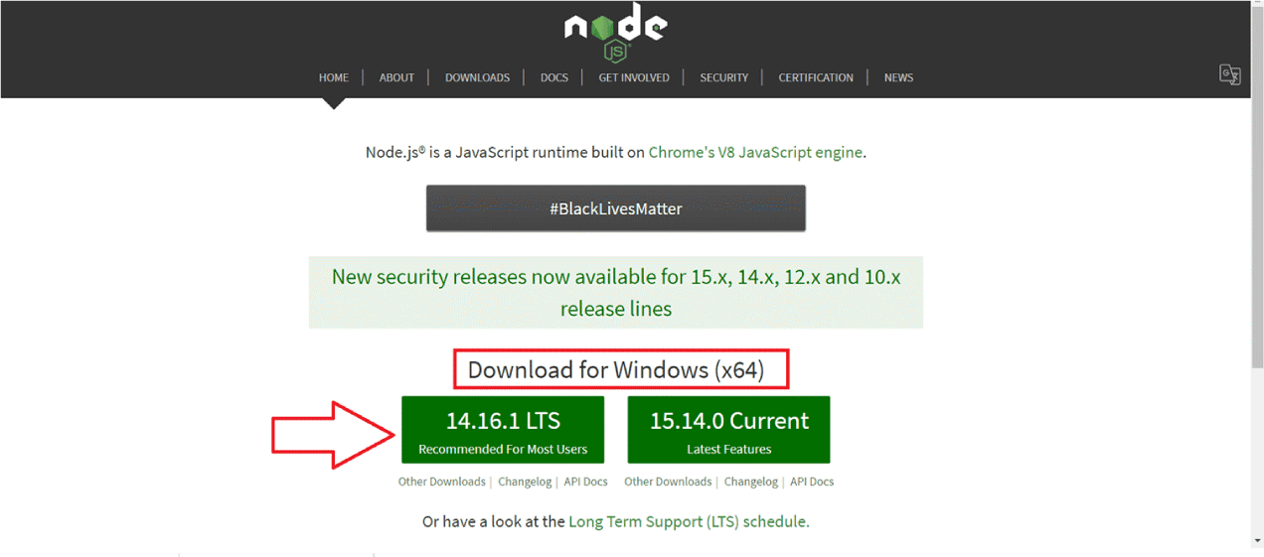

The LTS (Long-term Support) version is highly recommended for you. After downloading the installer package, install it with double-click on it.

Now .msi file will be downloaded to your browser. Choose the desired location for that.

### 

### 

### 

### **Step 2: Install Node.js and NPM**

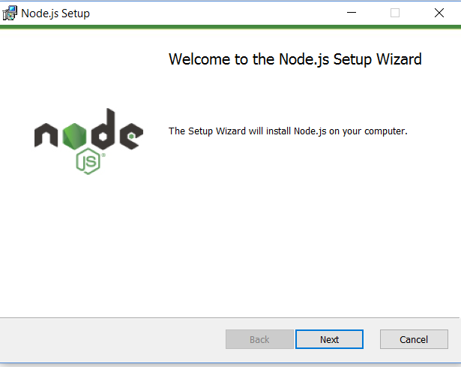

After choosing the path, double-click to install .msi binary files to initiate the installation process. Then give access to run the application.

You will get a welcome message on your screen and click the “Next” button. The installation process will start.

* Choose the desired path where you want to install Node.js.

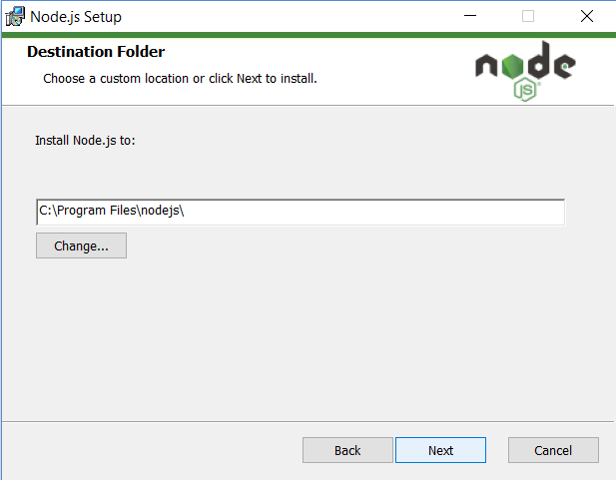

* By clicking on the Next button, you will get a custom page setup on the screen. Make sure you choose the npm package manager, not the default of Node.js runtime. This way, we can install Node and NPM simultaneously.

You should have 143MB of space to install Node.js and npm features.

The following features will be installed by default:

* Node.js runtime
* Npm package manager
* Online documentation shortcuts
* Add to Path

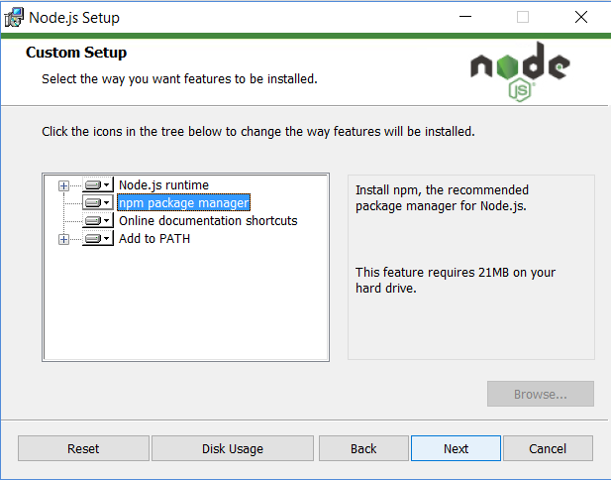

* Bang! The setup is ready to install Node and NPM. Let’s click on the Install button so hard!

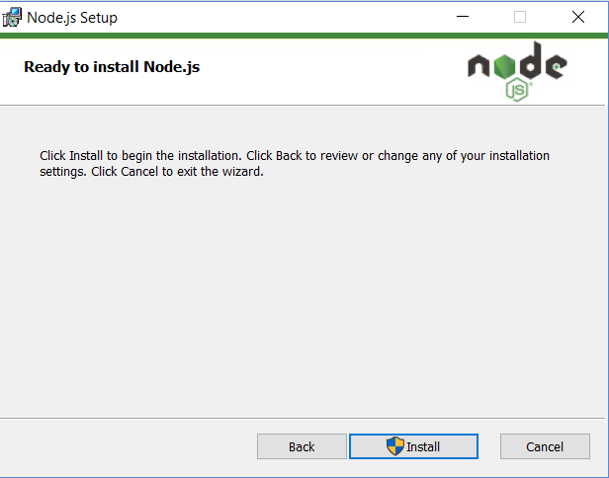

### **Step 3: Check Node.js and NPM Version**

* If you have a doubt whether you have installed everything correctly or not, let’s verify it with “Command Prompt”.

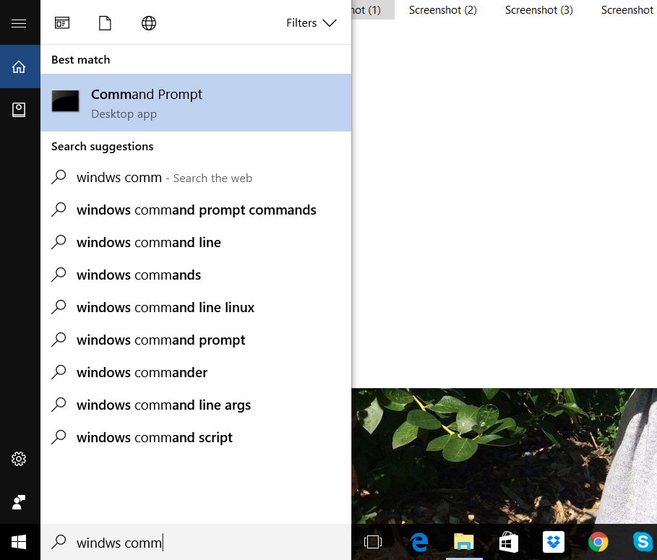

Command Prompt window will appear on the screen.

To confirm Node installation, type *node -v* command.

To confirm NPM installation, type *npm -v* command.

And you don’t need to worry if you see different numbers than mine as Node and NPM are updated frequently.

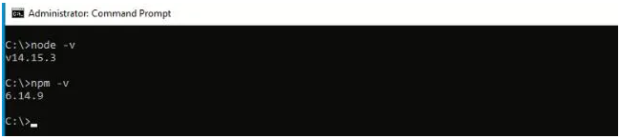

In my case, the version of node.js is v14.15.3 and npm is 6.14.9.

I3 How to Check the version of React Js?

To check which React version is your project using you need to open the package.json. Take a look under the dependencies section. It should list all of the dependencies of your project and one of those should be React.

"dependencies": {

"@testing-library/jest-dom": "^5.16.2",

"@testing-library/react": "^12.1.4",

"@testing-library/user-event": "^13.5.0",

"react": "^17.0.2",

"react-dom": "^17.0.2",

"react-scripts": "5.0.0",

"web-vitals": "^2.1.4"

}

You can clearly see that the current version of my local React project is 17.0.2.

I5 How to change in components of React Js?

We have to set the initial state value inside the constructor function and set the click event handler of the element upon which the click, results in changing state. Then pass the function to the click handler and change the state of the component inside the function using setState.

I6 How to Create a List View In React Js?

# React Lists

Lists are used to display data in an ordered format and are mainly used to display menus on websites. In React, Lists can be created in a similar way as we create lists in JavaScript. Let us see how we transform Lists in regular JavaScript.

The map() function is used for traversing the lists. In the below example, the map() function takes an array of numbers and multiplies

their values with 5. We assign the new array returned by map() to the variable multiplyNums and log it.

I7 How to Create a Text Input in React Js?

A1 Write a Command of Update NPM in React Js?

1. You can install the npm-check-update package globally to use this as CLI.

npm install -g npm-check-updates

ncu -u -f /^@syncfusion/

This will update the package.json file with the latest version of all @syncfusion packages.

1. Now, run the following commands to update the packages in node_modules and remove the duplicate package which is already installed.

npm update

npm dedupe

A2 Write all Command To create a Directory and First app In React js.

To create a new app/project using this tool, all we need to do is run the command "**create-react-app" followed by the app name**. After running the above command, a new folder called "my-sample-app" will get created and that would have all of our application code.

A3 Write a Command of How to create your First App as brijesh-app in React js and jay-app in React js?

npx create-react-app brijesh-app

npx create-react-app jay-app

A4 Write an example of How To Change in React Js as FollowingOutput